**GNANAMANI COLLEGE OF**

**TECHNOLOGY**

Departnament of BioMedical Engineering

III year

**TOPIC : SMART WATER FOUNTAINS**

**TEAM MEMBERS**

**M.ABARNA (620821121002)**

**N.ENISHA (620821121022)**

**R.MOHANADHARSHINI ( 620821121067)**

**J.DIVYAPRIYA (620821121021)**

**K.LOKESHWARI (620821121056)**

**By :**

**R.Mohanadharshini**

**SMART WATER FOUNTAINS**

The basic idea of this Arduino water fountain is to take an input from any external sound source like mobile, ipod, pc etc.., sample sound and brark it down to different voltage ranges, then use the output to turn on various relay . We first used as condensor mic based sound sensor module to perform on the sound sources to spilt the sounds into different voltages ranges. Then the voltage will be fed to op- amp to compare sound level with a. Particular limit The higher voltage range will correspond to a relay switch ON which comprises a musical water fountain operating to the beats and rythms of the song so here we are building this Musical fountain using Arduino and sound sensor

**MATERIALS REQUIRED**

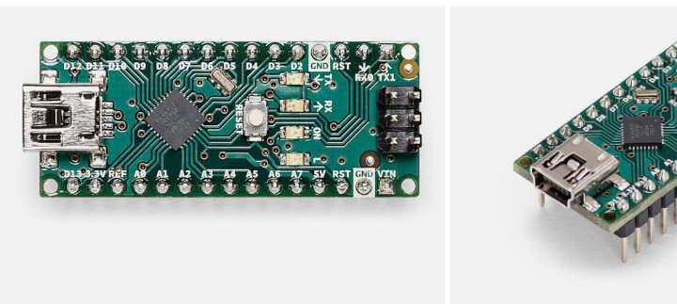

1. Arduino Nano
2. Sound sensor Module
3. 12v Relay module
4. DC pump
5. LEDs
6. Connecting wires
7. Vero based (or) Breadboard

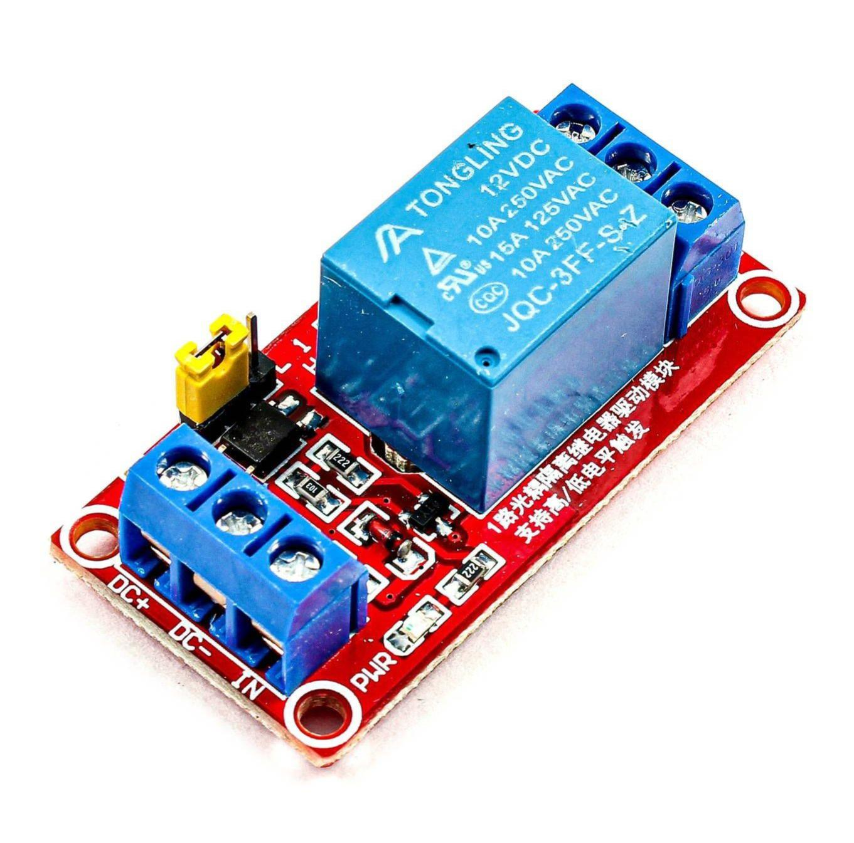

**WORKING OF A SOUND SENSOR**

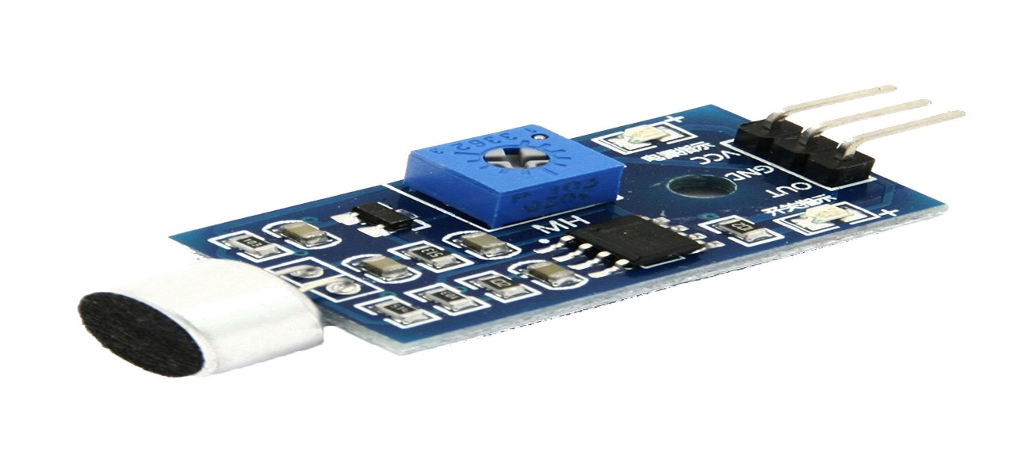 The sound sensor module is a simple electric Microphone based electronic board used to sense external sound from the environment. It is based on the LM393 power amplifier and an electret microphone ., It can be used to detect wether there is any sound beyond the set threshold limit. The module output is a digital signal which indicates that the sound is greater or lesser than the threshold

The potentiometers can be used to adjust the sensitivity of the sensor module . The module output is HIGH/ LOW when the sound source is Lower / high than the threshold set by the potentiometer same sound sensor module can also be used for measuring the sound level is decibel .

The complete program of this Arduino water fountain projects is given at the bottom of the page. But here I am just explaining that by parts for better understanding

int sensor = A6;

int redled = 12;

int greenled=11;

int pump = 10;

# define REF 700

delay (70) ;

}

Printmode (sensor, INPUT) ;

Pinmode (redled, OUTPUT) ;

Pinmode (greenlet, OUTPUT);

}

Void loop ()

{

int sensor – value = analog read sensor

if ( sensor – value > REF )

{

digitalwrite ( greenled, HIGH);

digitalwrite (redled, HIGH ) ;

digitalwrite (pump, HIGH) ;

delay (70);

}

else

{

digitalwrite ( greenled, LOW );

digitalwrite (redled, LOW);

digitalwrite (pump, LOW) ;

delay (70);

}

}

**PHASE 2**

**INNOVATION**

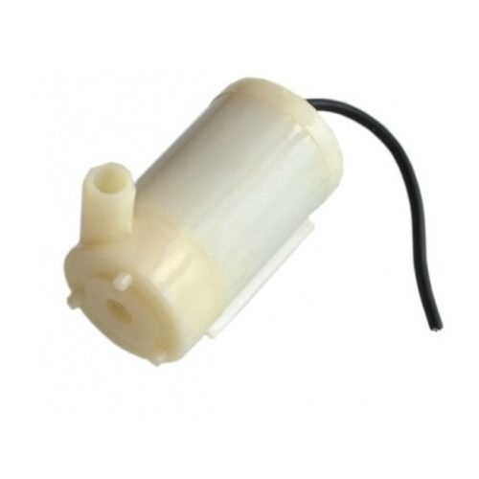

**1. Hydration Tracking:**

Create a water fountain that integrates with a smartphone app to track users' hydration levels. It could provide reminders to drink water based on individual needs and send data to health apps.

**2. Water Quality Monitoring:**

Install sensors to monitor water quality in real-time. Users can check water purity levels and receive alerts if any issues arise, promoting safe drinking.

**3. Touchless Operation:**

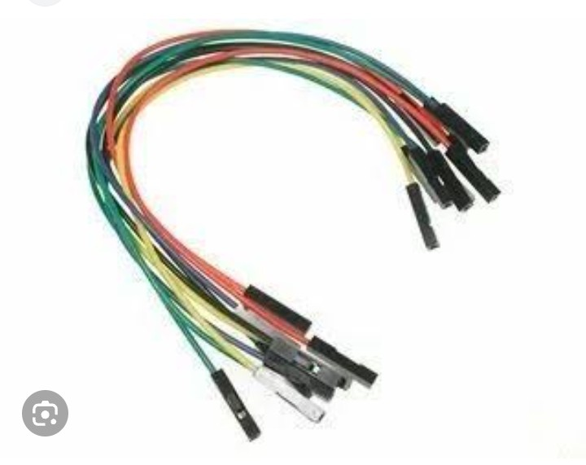Implement touchless or gesture-based controls to minimize the spread of germs. Users can activate the fountain without physically touching any buttons.

**4. Personalized Dispensing:**

Customize water temperature and carbonation levels to suit individual preferences. Users can choose between cold, room temperature, or sparkling water.

**5. Sustainability Features:**

Make the fountain eco-friendly by incorporating a water purification system and using materials that reduce waste and energy consumption.

**6. Voice Assistant Integration:**

Enable voice-activated controls using popular voice assistants like Alexa or Google Assistant for a seamless user experience.

**7. Water Usage Analytics:**

Collect data on water consumption patterns and offer insights to encourage users to reduce water waste and stay hydrated.

**8. Maintenance Alerts:**

Equip the fountain with sensors that detect maintenance needs and automatically send alerts to facility managers.

**9. QR Code Information:**

Display QR codes linking to information about the water source, filtration process, and sustainability efforts, promoting transparency.

**10. Bottle Refill Stations:**

Include bottle refill stations with customizable bottle-filling option

s, such as volume control and water temperature.

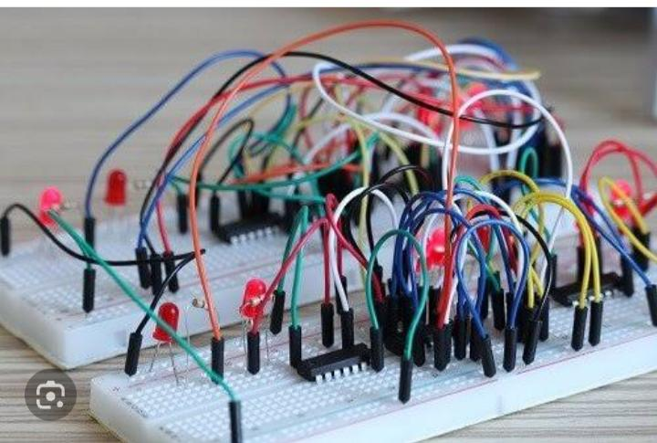

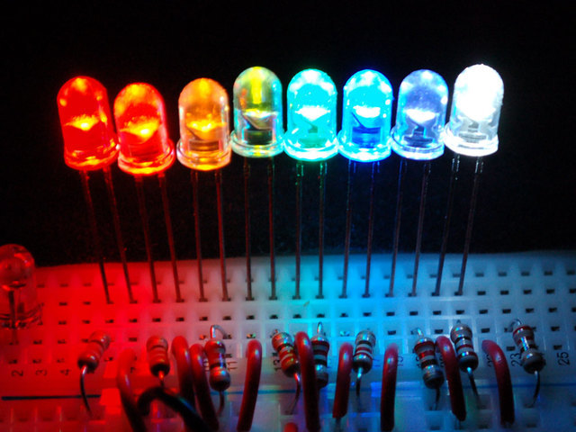

**11. User-Friendly Design:**

Focus on an ergonomic and aesthetically pleasing design that encourages people to use the fountain.

**12. Water Dispensing Games:**

Gamify the experience by adding interactive elements like quizzes or trivia that users can engage with while filling their water bottles.

**13. Eco-Education:**

Use digital displays to educate users about the importance of water conservation and sustainable practices.

**14. UV-C Sterilization:**

Incorporate UV-C sterilization technology to ensure that the fountain's dispensing area remains sanitary.

**15. Mobile App Integration:**

Allow users to locate nearby smart water fountains using a mobile app, making it convenient to find clean water on the go.

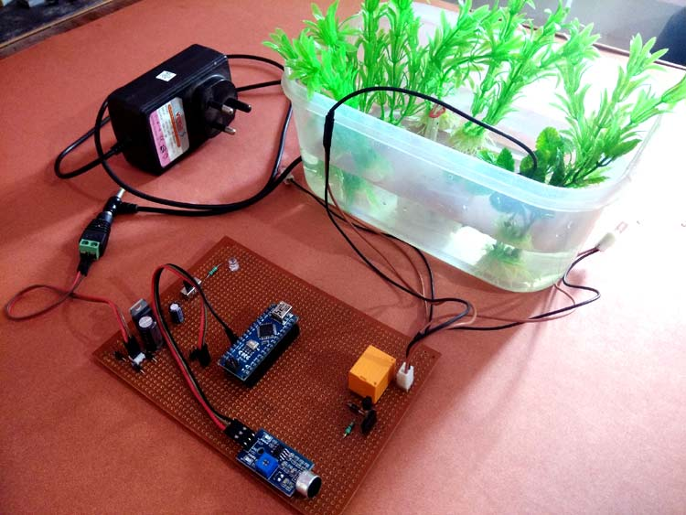

**FEATURES OF ENGINEERING:**

1. Water Quality MonitoringIntegrate sensors to measure water quality parameters like pH, turbidity, and temperature, and alert users when water needs treatment or replacement.

2. Automatic Refillin Implement an automatic water refill system to maintain an adequate water level, connecting it to a water source.

3. User InteractionEnable user-friendly interaction through touchscreens, voice commands, or smartphone apps to control water flow and other settings.

4. Water Flow ControlAllow users to adjust water flow rate, pressure, and pattern to suit their preferences or the needs of different plants or animals.

5. Filtration and Purification Include filtration and purification systems to ensure clean water supply for both humans and pets.

6. Energy Efficiency Use energy-efficient pumps and sensors to reduce power consumption and carbon footprint.

7. Water Recycling Incorporate a recycling system to reduce water wastage, particularly for outdoor fountains.

8. Remote Monitorin Provide users with the ability to monitor the water fountain remotely, receive notifications, and access historical data through a cloud-based platform.

9. Customized SchedulesAllow users to set schedules for water fountain operation, optimizing water usage.

10. Safety FeaturesImplement safety features like overflow sensors to prevent flooding and secure electrical components against water damage.

11. Data Analytics Use data analytics to provide insights into water consumption, usage patterns, and trends to help users make informed decisions.

12. Water Conservation TipsOffer users water conservation tips and suggestions based on their usage patterns and local weather conditions.

13. Aesthetic CustomizationAllow users to customize the fountain's appearance and lighting to match their decor or outdoor environment.

14. Integration with IoT Ecosystem Integrate with other smart home devices or IoT ecosystems, such as connecting with weather stations for adaptive water scheduling.

15.User ProfilesCreate user profiles to store individual preferences and usage history for a personalized experience.

16. Self-Cleaning Mechanism Include a self-cleaning mechanism to reduce the need for manual maintenance.

17. Water Temperature ControlRegulate water temperature for specific applications like fish ponds or hydroponic systems.

18. Water Fountain Health MonitoringUse sensors to monitor the health and performance of the fountain's components, providing maintenance alerts.

19. Water Consumption StatisticsProvide users with statistics on water consumption and its environmental impact.

20.Water Usage ReportsGenerate reports that detail water usage and cost savings over time

Data Collection: Collect data from various sensors in or around the water fountain, such as water level sensors, temperature sensors, and occupancy sensors. This data will be used to train the model

**MODEL TRAINING:**

Data Preprocessing: Clean and preprocess the data to remove noise and outliers, and format it for machine learning. Ensure that the data is labeled appropriately, indicating when the fountain should be turned on or off.Selecting a Model: Choose an appropriate machine learning model for your task. For binary control (on/off), you can use classification algorithms like decision trees, support vector machines, or neural networks.Feature Engineering:

Create relevant features from the sensor data that can help the model make informed decisions.

For example, you might want to consider time of day, weather conditions, and historical data.Model Training:

Split your data into training and testing sets. Train your chosen model on the training data, adjusting hyperparameters as needed for optimal performance.Evaluation

Assess the model’s performance using the testing data, using metrics such as accuracy, precision, recall, or F1 score, depending on your specific requirements

Model Optimization: Fine-tune the model based on the evaluation results.

This may involve adjusting model parameters, using more advanced techniques like deep learning, or employing ensemble methods.Integration

Integrate the trained model into the smart water fountain system. This typically requires connecting the model to the fountain’s control mechanism, such as a microcontroller or IoT device.Testing and Validation

Thoroughly test the system in real-world conditions to ensure it functions as expected and responds appropriately to sensor inputs.

**EVALUATION:**

1. Functionality Assess whether the components are suitable for the intended purpose. The sound sensor should reliably detect sound, the pump should provide adequate water flow, and the LEDs should illuminate as desired.

2. Compatibility Ensure that the components are compatible with each other and with the Arduino Nano. Verify voltage and current requirements to avoid damaging any components.

3. Arduino ProgrammingEvaluate the complexity of programming the Arduino Nano to control the pump and LEDs based on sound sensor input. Ensure that the code is efficient and error-free.

4. Power SupplyDetermine if the 12V power supply for the pump is appropriate and whether it can be safely integrated into the project. Consider the power consumption of all components.

5. SafetY Consider safety measures, such as waterproofing components to prevent electrical damage and ensuring secure power connections.

6. Assembly and WiringAssess the ease of assembly and the organization of wiring on the breadboard. Neat and well-organized wiring can make troubleshooting easier.

7. CostCalculate the total cost of components and materials to ensure it aligns with your budget.

8. ReliabilityConsider how reliable the system is in detecting sound and functioning consistently over time. Are there any potential failure points or reliability issues to address?

9. AestheticsEvaluate the aesthetic appeal of the smart water fountain, as this can be important if it's for decorative purposes.

10. Documentation Check if you have comprehensive documentation for the project, including a clear wiring diagram, code, and instructions for future maintenance.

11. User ExperienceConsider the end-user experience and whether the smart water fountain meets its intended purpose effectively and efficiently.

12. Scalability and Expandability Determine if the project can be scaled up or expanded in the future if desired.